PRINTING AND MAILING SERVICES RFP QUESTIONS

Note: 3CE received a number of technical questions pertaining to paper size and weight, inks, digital file types, etc. Applicants should use their best judgment regarding sizes and weights, as these variables are subject to change and will be finalized during the design process. Please assume that files will be provided in the format you need within the Microsoft or Adobe app suites.

Under requirement #2: Can you define a low and high range for Enrollment Notification Mailers and Required mailers?
The final enrollments contemplated by 3CE will involve about 74,000 new customers. The current number of Required mailers (not including those new customers) is roughly 95,000. Note that the majority of enrolled customers receive their required notifications via email rather than USPS.

The RFP states: Each year, the California Public Utilities Commission requires 3CE to send two unique mailers to all customers (Currently approximately 440,000 and projected to be approximately 515,000 after January 2025); the Joint Rate Mailer and the Power Content Label. These two annual mailers typically go out mid-year and in the fall, respectively.
Why are these two mailings not included in the pricing exercise?
These mailers are in the scope of work; the quantities reflect the number of customers who receive these required mailings by USPS rather than via email.
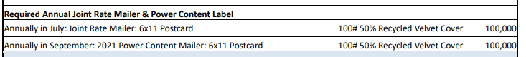

I don’t see any reference to ink – are these printed all black or full color?
Printing is full color.

Are these mailings sent first class or standard class?...or a combination of both?
Standard unless it is a rush delivery, in which case first class.

Do the 6 x 11 postcards mail as flats or are they folded & tabbed?
They mail flat.

In the General Noticing & Mailers section the Move in/out letters are also called postcards? Which are they?
They are postcards.

We would propose using only two different paper weights: 100# for postcards and 80# for everything else, all recycled – would bidding this way disqualify us?
No, that would not be disqualifying.

Our corporate office is in Paso Robles, is our location within the service area?
The street address provided is within 3CE’s service area.

